

DEPARTMENT OF COMPUTER SCIENCE AND ENGINEERING

CSA05-DATABASE MANAGEMENT SYSTEMS
DDL Commands – CREATE, ALTER, DROP
STUDENT NAME : R Charulatha
REGISTER NUMBER: 1924260033
COURSE CODE: CSA0507
COURSE NAME: Database Management System
SLOT: A

AIM:
To Create, Alter, Drop, Rename, Truncate using Data Definition Language (DDL) statements.

Description:
Data Definition Language (DDL) statements are used to define the database structure or schema.
DDL Commands: Create, Alter, Drop, Rename, Truncate
- CREATE - to create objects in the database
- ALTER - alters the structure of the database
- DROP - delete objects from the database
- TRUNCATE - remove all records from a table, including all spaces allocated for the records are removed
- RENAME - rename an object

SYNTAX: CREATE TABLE
CREATE TABLE table_name (
column_name1 data_type, column_name2 data_type, column_name3 data_type,
....
);

ALTER A TABLE
To add a column in a table ALTER TABLE table_name ADD column_namedatatype;

To delete a column in a table

ALTER TABLE table_name DROP COLUMN column_name;

DROP TABLE
DROP TABLE table_name;

TRUNCATE TABLE
TRUNCATE TABLE table_name;

Questions:
- Create a table name STUDENT with following structure.

# | Column Name | Description | Data Type
1 | RegNo | Registration Number | NUMBER(3)
2 | Name | Student Name | VARCHAR(15)
3 | Gender | Gender of the student | CHAR(1)
4 | DOB | Date of Birth | DATE
5 | MobileNo | Mobile Number | NUMBER(10)
6 | City | Location of stay | VARCHAR(15)

- Create a table name FACULTY with following structure.

# | Column  Name | Description | Data Type
1 | FacNo | Faculty Identifier | VARCHAR(4)
2 | FacName | Faculty Name | VARCHAR(15)
3 | Gender | Gender of faculty | CHAR(1)
4 | DOB | Date of Birth | DATE
5 | DOJ | Date of Join | DATE
6 | MobileNo | Mobile Number | NUMBER(10)

- Create a table name DEPARTMENT with following structure.

# | Column  Name | Description | Data Type
1 | DeptNo | Department Identifier | VARCHAR(4)
2 | DeptName | Department Name | VARCHAR(15)
3 | DeptHead | Department Head | VARCHAR(4)

- Create a table name COURSE with following structure.

# | Column  Name | Description | Data Type
1 | CourseNo | Course Identifier | VARCHAR(3)
2 | CourseDesc | Course  Description | VARCHAR(14)
3 | CourseType | Course Type | CHAR(1)
4 | SemNo | Semester Number | CHAR(1)
5 | HallNo | Hall Number | VARCHAR(4)
6 | FacNo | Faculty Identifier | VARCHAR(4)
- Modify the table FACULTY by adding a column name Dept of datatype VARCHAR(10)

OUTPUTS:

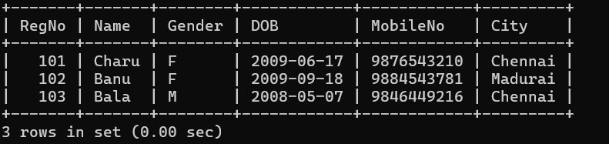

2)

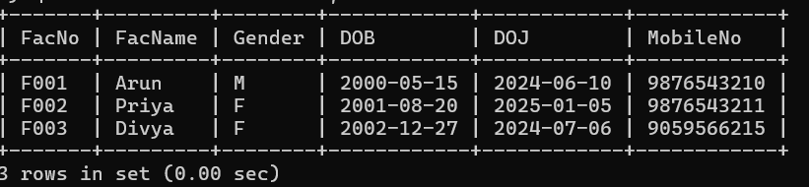

3)

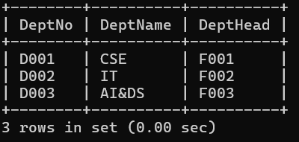

4)

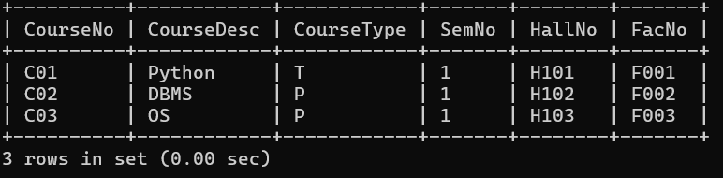

5)

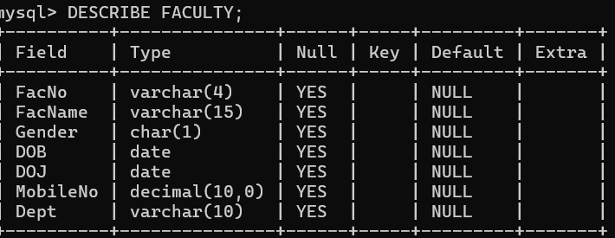

RESULT:
Tables are created, altered and modified using DDL commands.

DDL Commands with Constraints – PRIMARY, FOREIGN KEY, UNIQUE, CHECK

AIM:
To add the constraints like primary key, foreign key, unique key and check using DDL commands.

Description:

PRIMARY KEY:
The PRIMARY KEY constraint uniquely identifies each record in a database table. Primary keys must contain UNIQUE values, and cannot contain NULL values.
A table can have only one primary key, which may consist of single or multiple fields.

FOREIGN KEY:
- A FOREIGN KEY is a key used to link two tables together.
- A FOREIGN KEY is a field (or collection of fields) in one table that refers to the PRIMARY KEY in another table.
- The table containing the foreign key is called the child table, and the table containing the candidate key is called the referenced or parent table.

UNIQUE Constraint:
- The UNIQUE constraint ensures that all values in a column are different.
- Both the UNIQUE and PRIMARY KEY constraints provide a guarantee for uniqueness for a column or set of columns.
- A PRIMARY KEY constraint automatically has a UNIQUE constraint.
- However, you can have many UNIQUE constraints per table, but only one PRIMARY KEY constraint per table.

CHECK Constraint:
- The CHECK constraint is used to limit the value range that can be placed in a column
- If you define a CHECK constraint on a single column it allows only certain values for this column.
- If you define a CHECK constraint on a table it can limit the values in certain columns based on values in other columns in the row.

PRIMARY:
ALTER TABLE table_name
ADD PRIMARY KEY(primary_key_column);

FOREIGN KEY:
ALTER TABLE table_name
ADD CONSTRAINT constraint_name FOREIGN KEY foreign_key_name (columns) REFERENCES parent_table(columns)
ON DELETE action ON UPDATE action

UNIQUE:
CREATE TABLE table_1(
...
column_name_1 data_type,
...
UNIQUE(column_name_1)
);

CHECK
CREATE TABLE IF NOT EXISTS parts ( part_no VARCHAR(18) PRIMARY KEY,
description VARCHAR(40),
cost DECIMAL(10 , 2 ) NOT NULL CHECK(cost > 0), price DECIMAL (10,2) NOT NULL
);

Questions:
- Alter the table STUDENT2 with following structure.

# | Column Name | Constraints
1 | RegNo | PRIMARY KEY

- Alter the table name FACULTY with following structure.

# | Column Name | Constraints
1 | FacNo | PRIMARY KEY
2 | Gender | CHECK ‘M’ or ‘F’

- Alter the table name DEPARTMENT with following structure.

# | Column Name | Constraints
1 | DeptNo | PRIMARY KEY

- Alter the table name COURSE with following structure.

# | Column Name | Constraints
1 | CourseNo | PRIMARY KEY
2 | SemNo | 1 to 6

- Alter the table name STUDENT2 with following structure.

# | Column Name | Constraints
1 | S1Name | UNIQUE KEY
- After the STUDENT2 & STUDENT3 tables are successfully created, test if you can add a constraint FOREIGN KEY to the RegNo of this table.

OUTPUTS:

1)

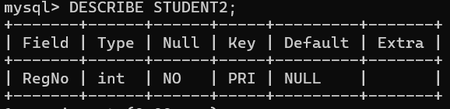

2)

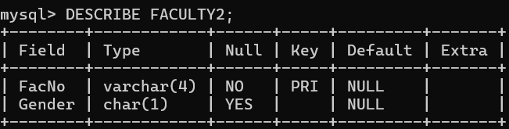

3)

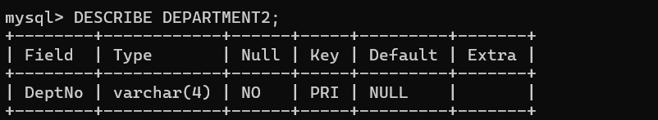

4)

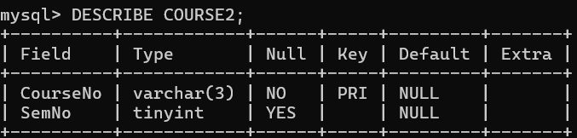

5)

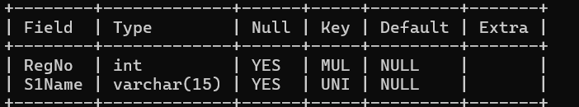

6)

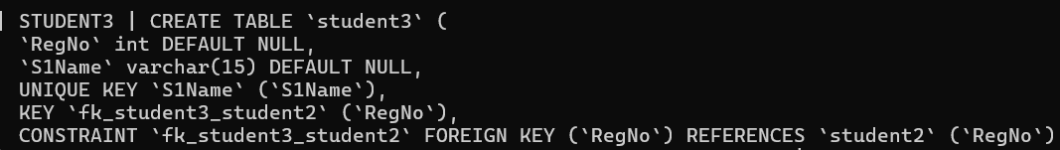

Result:
DDL Commands with Primary, Foreign, Unique, Check constraints are updated and verified.

Ex.No. : 3
Date:

Aim:

DML Commands – INSERT, SELECT

To perform Data Manipulation Language (DML) Commands such as INSERT, SELECT in the table.

Description:

Data Manipulation Language (DML) statements are used for managing data within schema objects. DML Commands: Insert, Select
- INSERT - insert data into a table
- SELECT - retrieve data from the a database

INSERT:
INSERT INTO table_name VALUES (value1, value2, value3,...); ( or )
INSERT INTO table_name (column1, column2, column3,...) VALUES (value1, value2, value3,...);

SELECT:
SELECT column_name(s) FROM table_name;

Questions:
- Populate all the five tables with your own data.
- View all the records from the five tables.

OUTPUTS:
1)
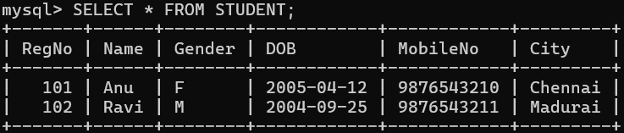

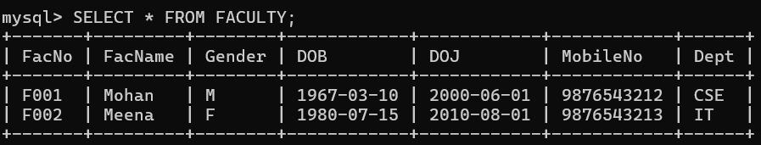

2)
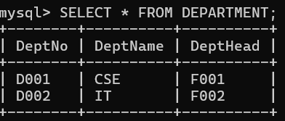

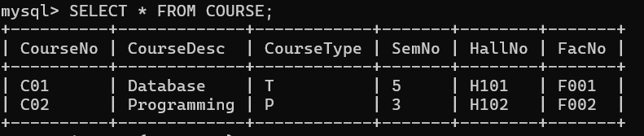

RESULT:
Data Manipulation Language (DML) Commands such as INSERT, SELECT are performed in the five tables.

Ex.No. : 4
Date:

Aim:

DML Commands with Constraints –UPDATE, DELETE

To perform Data Manipulation Language (DML) Commands such as UPDATE, DELETE in the table.

Description:

Data Manipulation Language (DML) statements are used for managing data within schema objects. DML Commands: Update, Delete
- UPDATE - updates existing data within a table
- DELETE - deletes all records from a table, the space for the records remain

UPDATE:
UPDATE table_name
SET column1=value, column2=value2,... WHERE some_column=some_value;

DELETE:
DELETE FROM table_name WHERE some_column=some_value;

Questions:
- Update the value of student name whose register number is ‘191711342’
- Delete the record in the table FACULTY, who resigned her job.
- Modify the age for the faculty whose name is 'mohan' with a value ‘59’.
- Remove all faculty who are having over 65 years

OUTPUTS:
1)
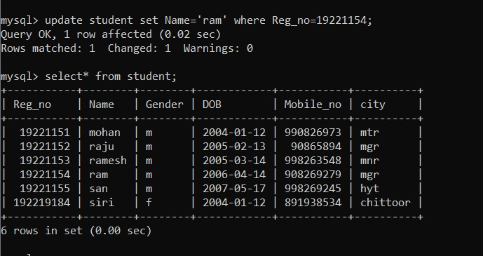
2)

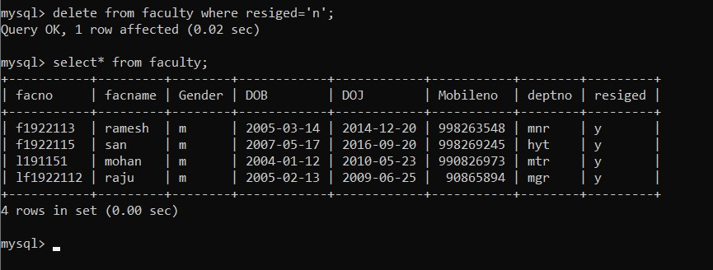
3)

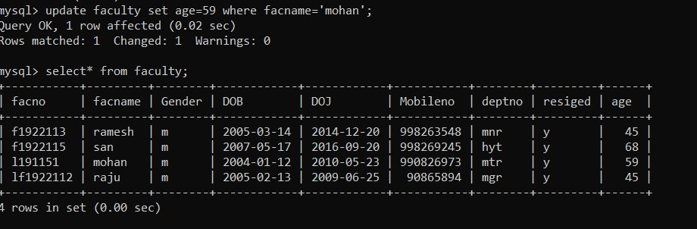

4)
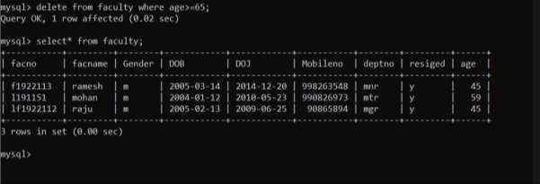

RESULT:
Data Manipulation Language (DML) Commands such as UPDATE, DELETE are performed in the five tables.

